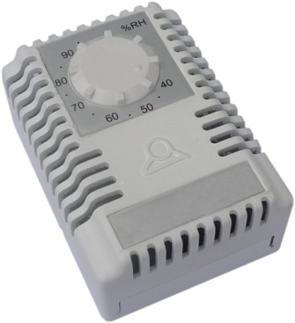

**Type Q7B**

**Wall mounting miniature humidistat**

Main Application: This humidistat is designed for indoor application to switch on a heater or a ventilating fan. It can also be used to switch on humidifiers, dehumidifiers, or other devices. It must be vertically wall mounted in a ventilated area.

Setting range: 35 to 95% RH.

Measuring accuracy: ±5% RH.

Measuring medium: air, pressure-less, non-aggressive.

Electrical contact: silver contacts, SPDT, 5A 250V.